# **CTF Topic: Introduction to Penetration**

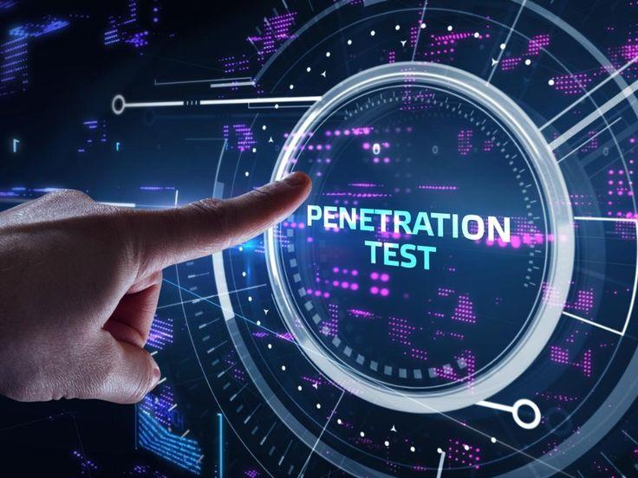

# **Introduction**



Penetration testing, commonly known as pen testing, is a simulated cyber attack conducted against computer systems, networks, or applications to uncover vulnerabilities and assess security measures. It's a proactive approach to identifying and addressing potential security risks before malicious actors can exploit them.

# **Why Penetration is Needed**

**1. Risk Mitigation**: To identify and mitigate potential security risks before they are exploited by attackers.

**2. Compliance**: Many industries and regulations require regular penetration testing to meet compliance standards.

**3. Enhance Security Posture**: By identifying weaknesses, organizations can improve their overall security posture.

**4. Prevent Data Breaches**: Finding and fixing vulnerabilities helps prevent unauthorized access and data breaches.

**5. Build Trust**: Demonstrating a commitment to security builds trust with customers, partners, and stakeholders.

# **How to implement penetration**

Penetration testing involves several steps and methodologies, usually carried out by cybersecurity professionals using specialized tools and techniques. The implementation includes the following phases:

### Steps of Penetration and Tools Required

1. **Planning**: Define scope, objectives, and rules of engagement.
   * **Tool**: Project management software.
2. **Reconnaissance**: Gather information about the target system and its environment.
   * **Tools**: Nmap, Shodan, WHOIS lookup tools.
3. **Scanning**: Identify open ports, services, and vulnerabilities.
   * **Tools**: Nessus, OpenVAS, Nikto.
4. **Gaining Access**: Exploit vulnerabilities to gain unauthorized access.
   * **Tools**: Metasploit, Burp Suite, SQLMap.
5. **Maintaining Access**: Maintain persistent access and assess potential damage.
   * **Tools**: Netcat, Meterpreter.
6. **Analysis and Reporting**: Document findings, assess impact, and provide recommendations.
   * **Tools**: Reporting templates, and vulnerability management platforms.

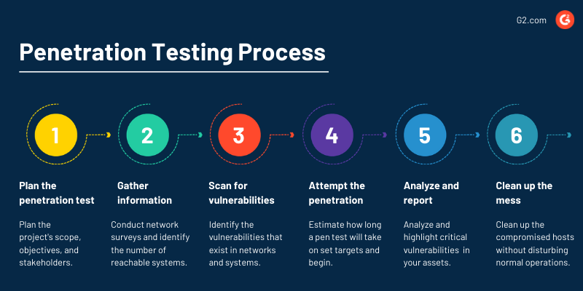

# **Question**

**Flag1: what is the purpose of penetration testing?**

**Answer: Security**

**Flag 2: why is penetration testing necessary for organizations?**

**Answer: Protection**

**Flag 3: What is the initial phase of penetration testing?**

**Answer: Planning**

**Flag4: what is a common tool used for scanning in penetration?**

**Answer: Nessus**

**Flag 5: What is the final and most important step in the penetration testing process ?**

**Answer: Reporting**